DevOps Project – 2
Objective: Integrate Jenkins and Docker and run a container to deploy a webpage.
Step: 1
Create two ec2 instances.
1. Docker
2. Jenkins
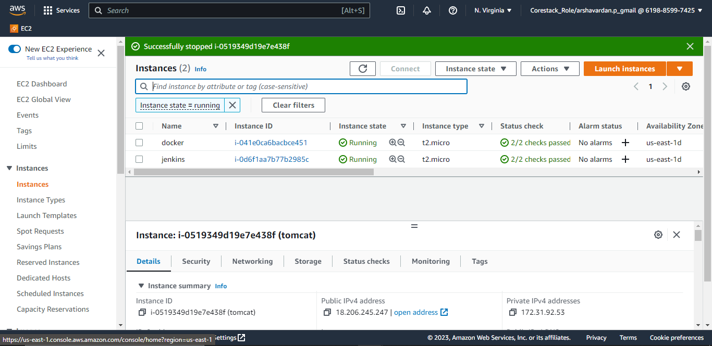

Step 2:
Setup Jenkins
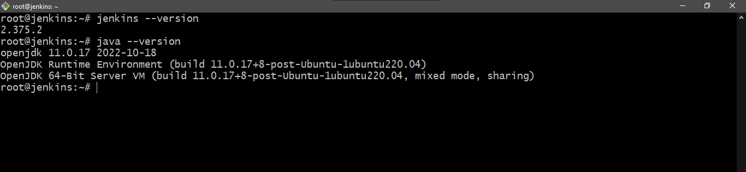
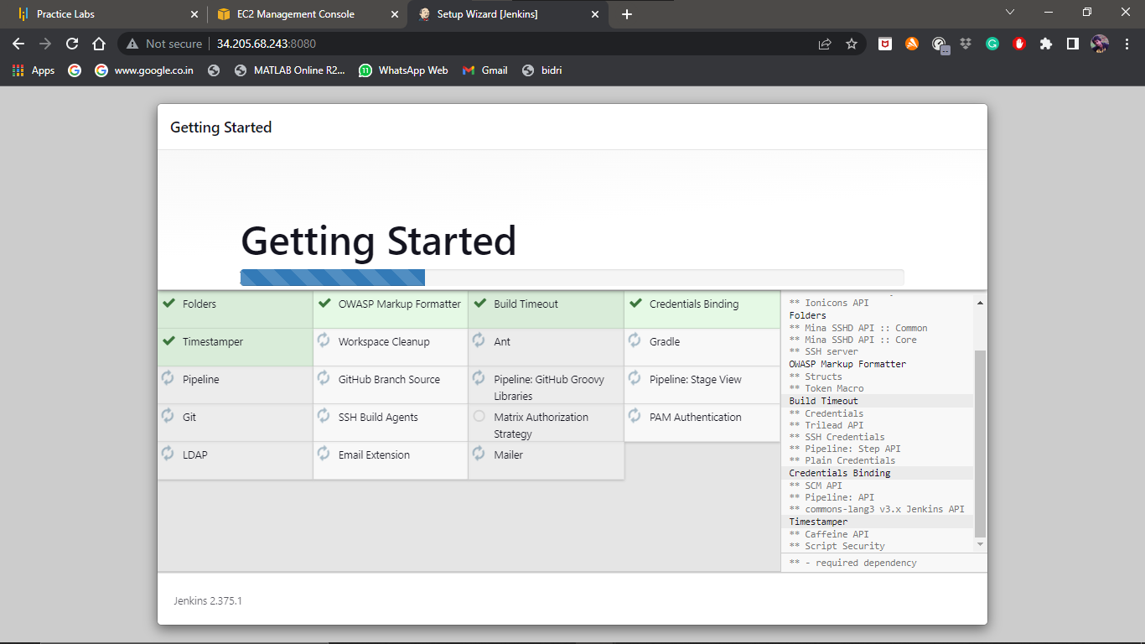
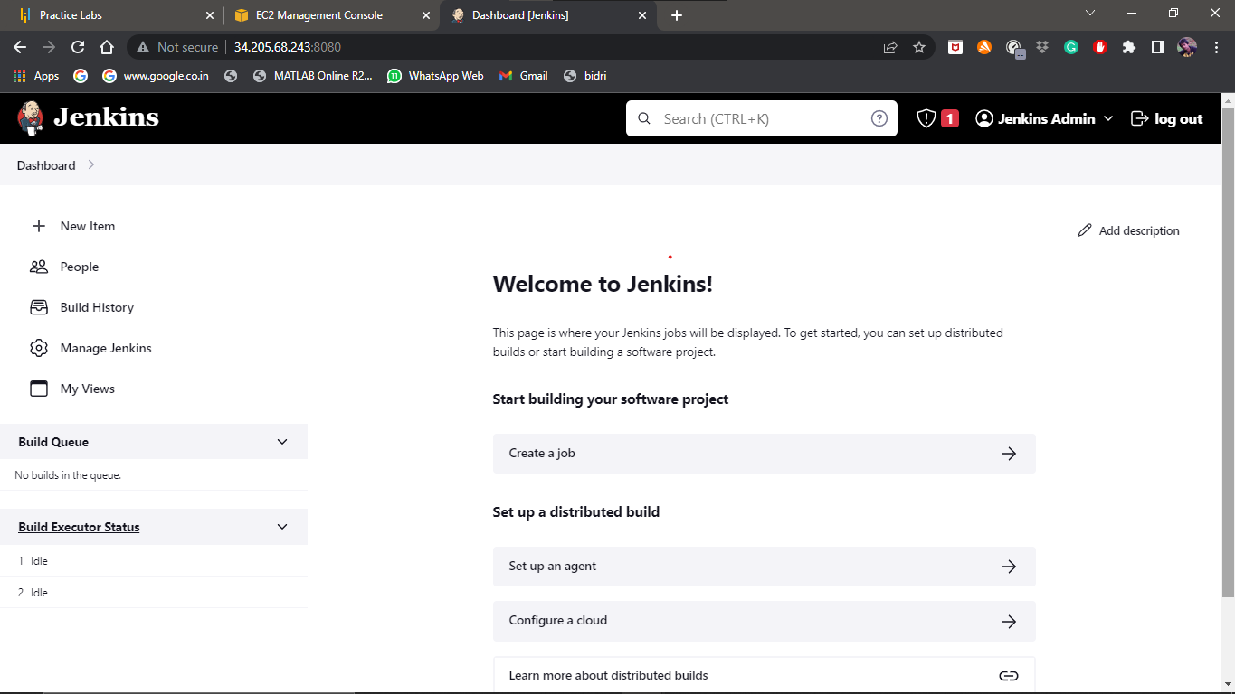
Installing plugins: Publish over ssh and configure to the docker
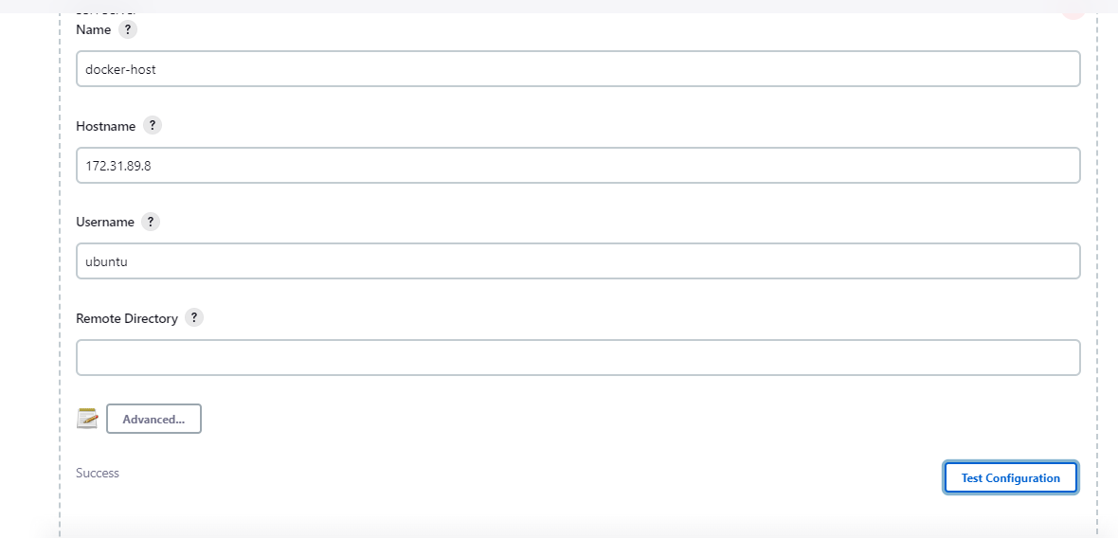

Fetching the free template from the website: https://www.tooplate.com/view/2132-clean-work
Downloading the .zip file link. 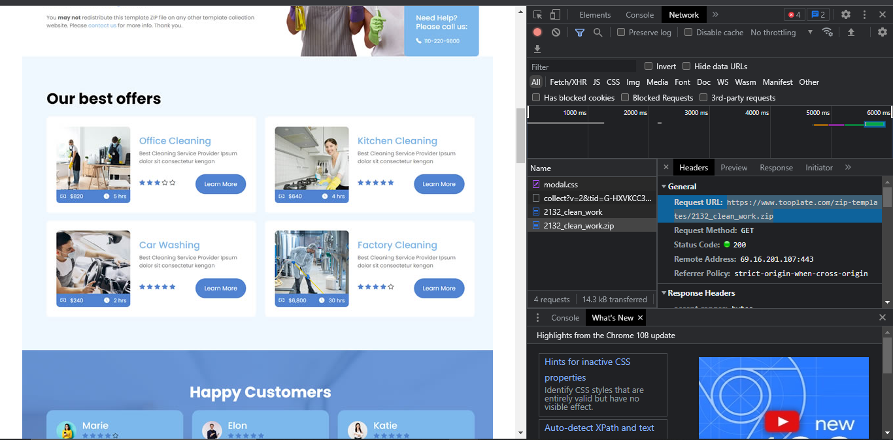

https://www.tooplate.com/zip-templates/2132_clean_work.zip

step: 3
Running the following steps:
- Unzipped the file and added the file to the GitHub.
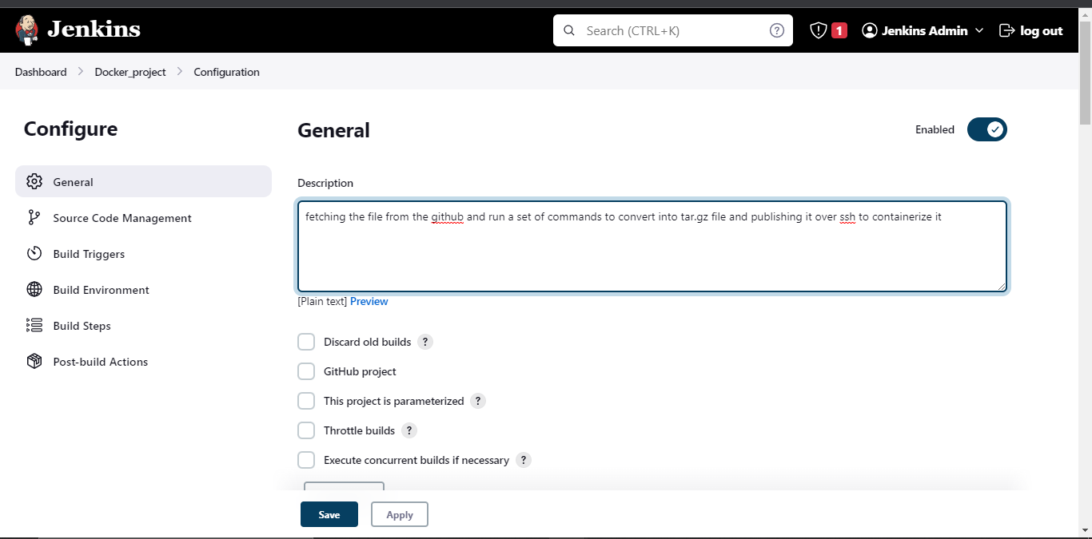
- Creating a freestyle project in Jenkins – Docker-Project

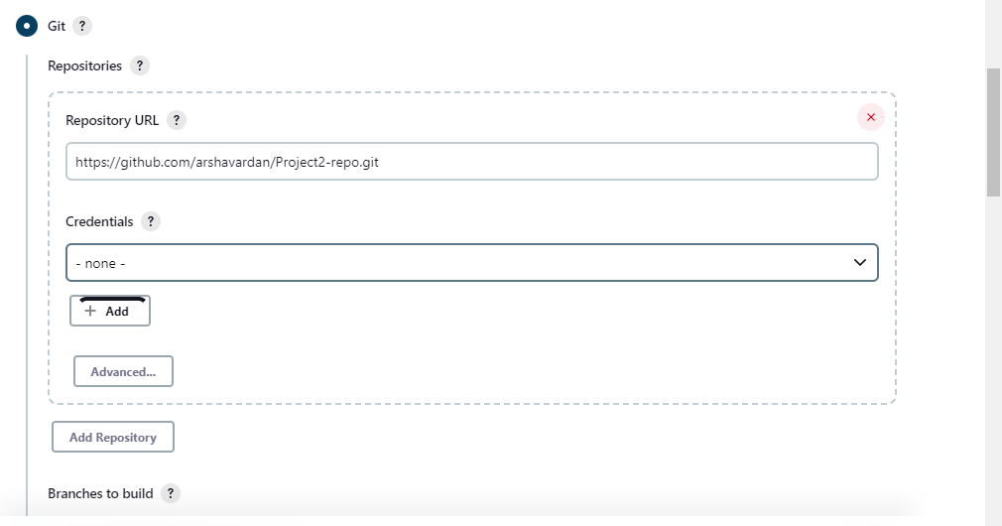
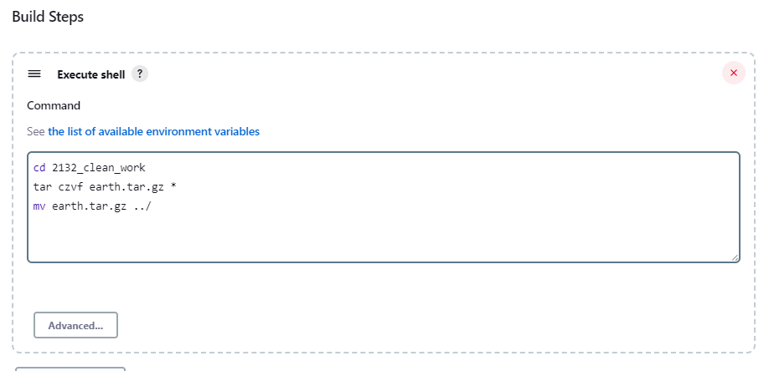

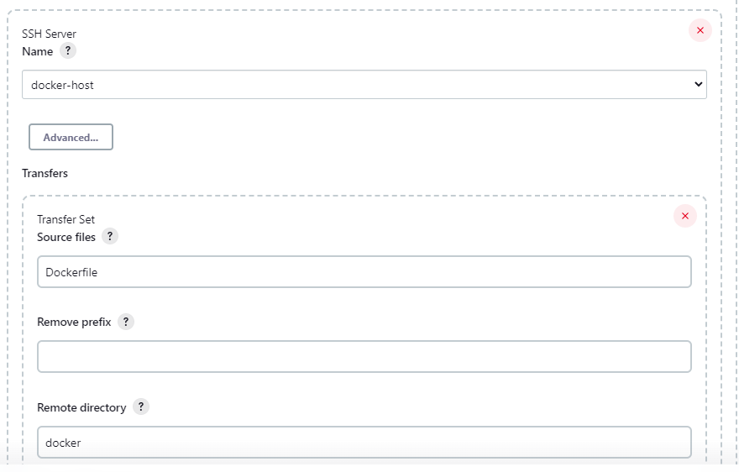
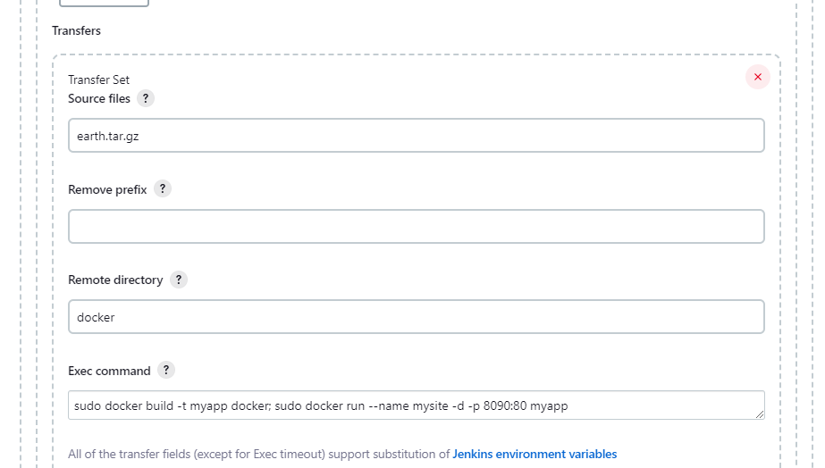

Step: 4
- Write a Dockerfile in the Jenkins workspace.
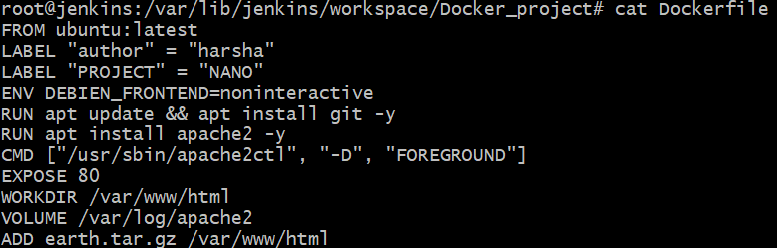

- This Dockerfile along with the *.tar.gz will be sent over to the Docker file in the docker server, once the build is executed, as shown below
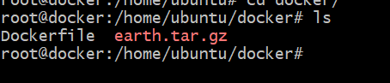
Step : 5
Executing the build in the Jenkins.
Commands used in the jenkins are as follows:
- cd 2132_clean_work
- tar czvf earth.tar.gz *
- mv earth.tar.gz ../
- sudo docker build -t myapp docker
- sudo docker run --name mysite -d -p 8090:80 myapp

Step: 6
RESULTS:
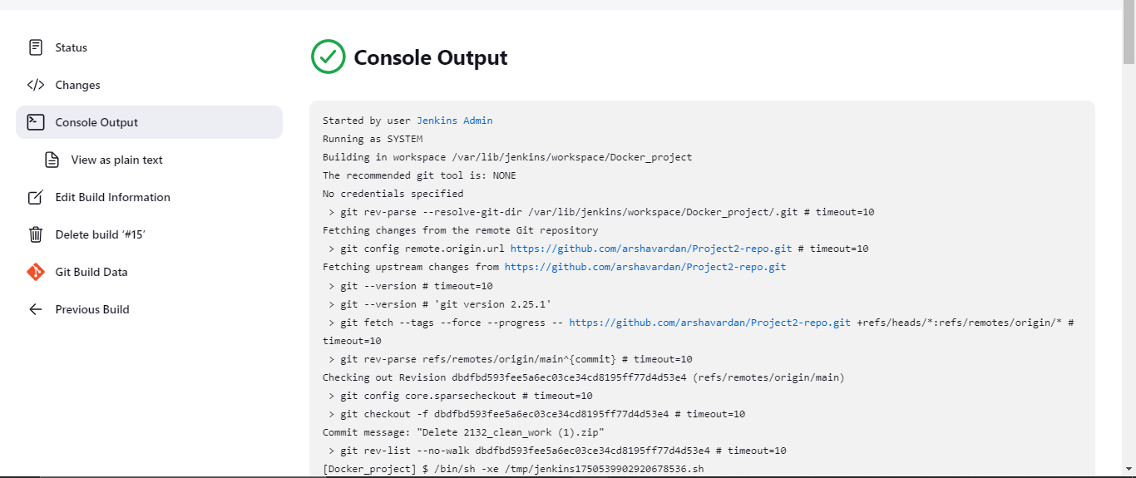
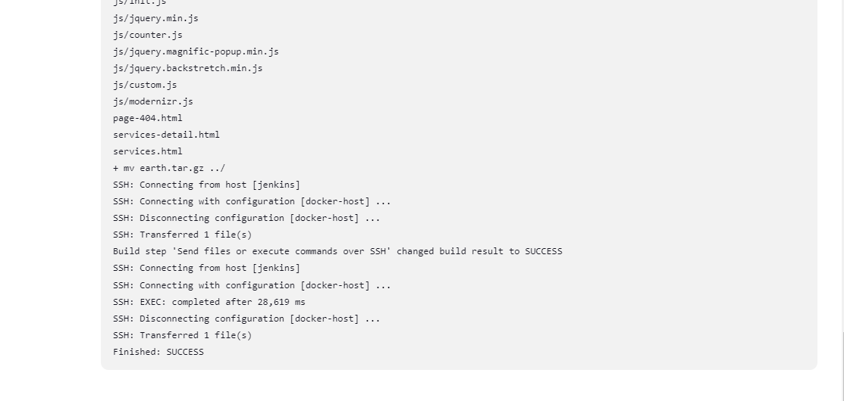

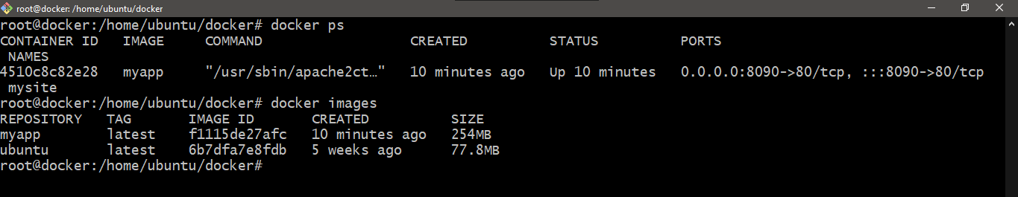

Opening the IP address in the browser with port 8090:


Pushing the image to the Dockerhub.
